Audit Scope and Goals

Summary

Step one

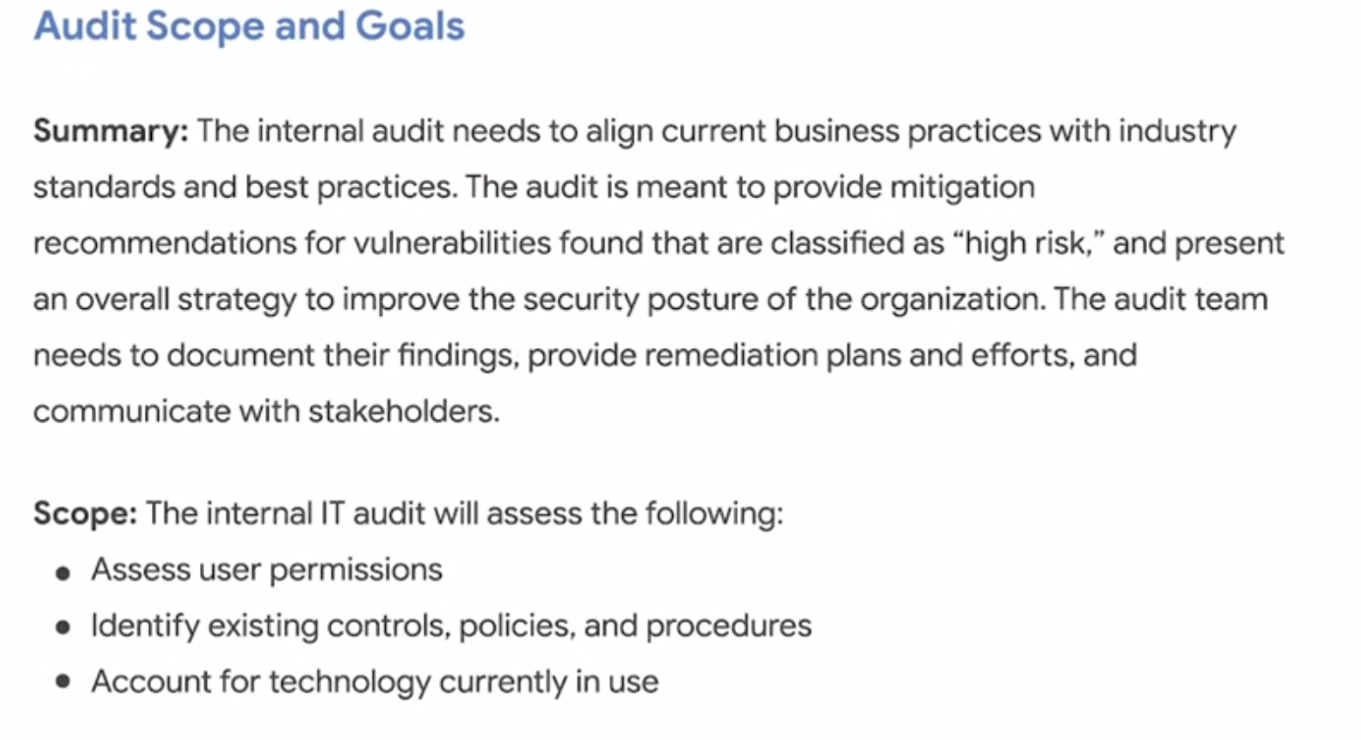

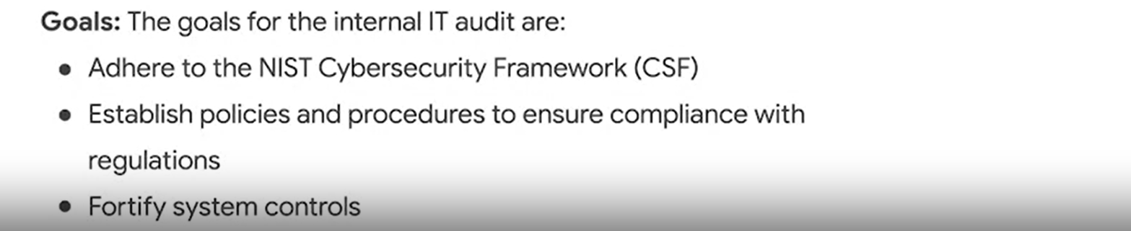

Step two: Conducting Risk Assessment

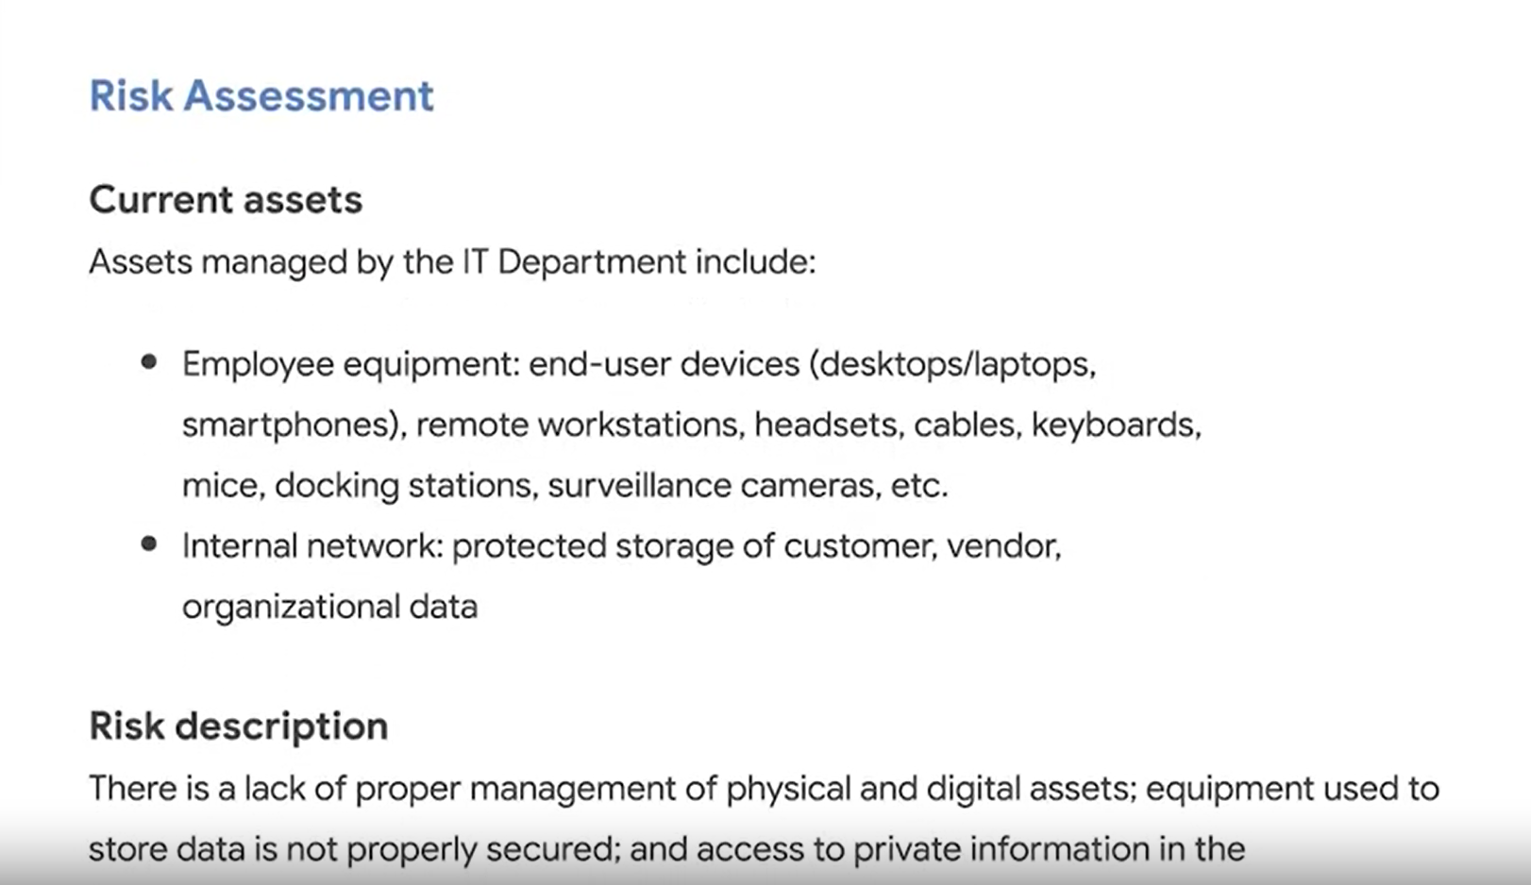

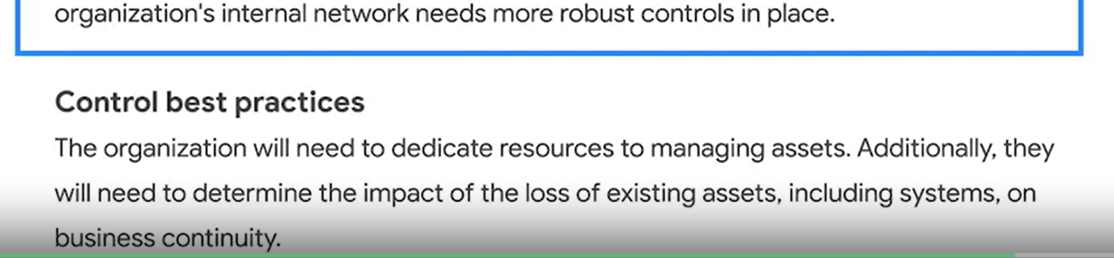

3. Completing a control assessment

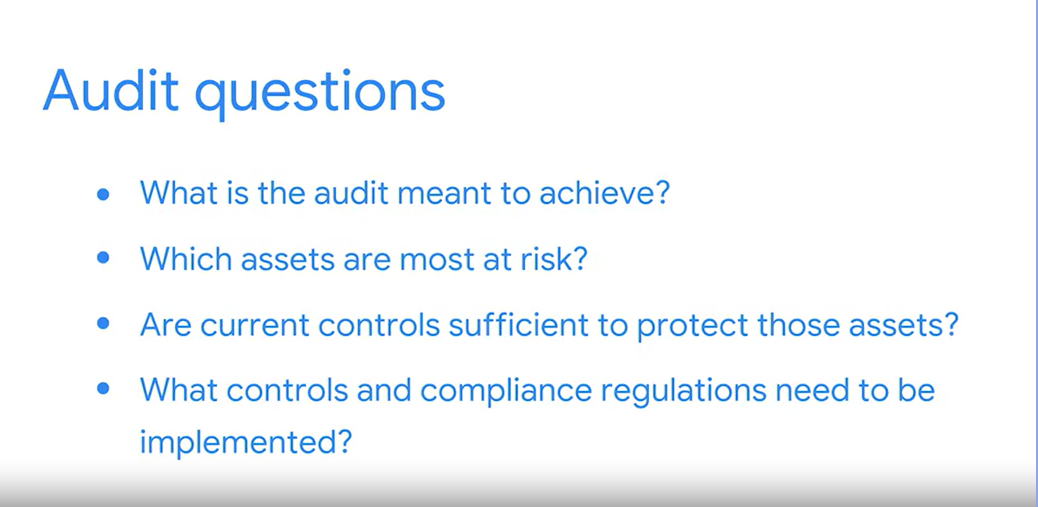

Typesof Controls

1. Administrative Controls which deals with human component of cybersecurity

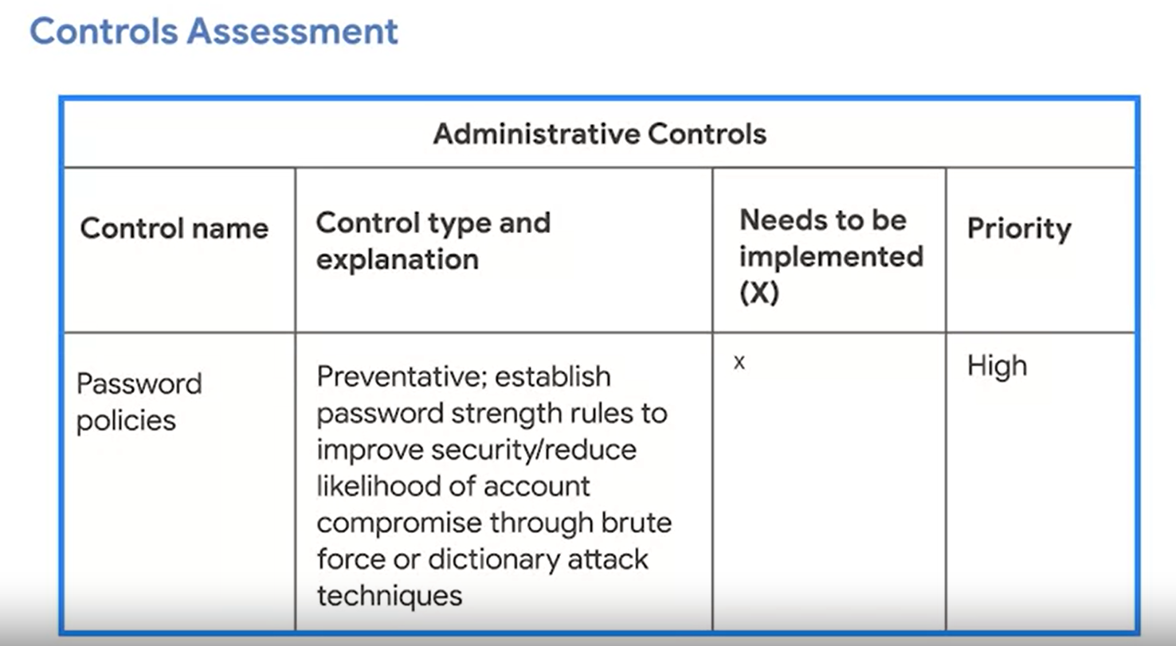

1. Technical controls are hardware and software solutions used to protest assets

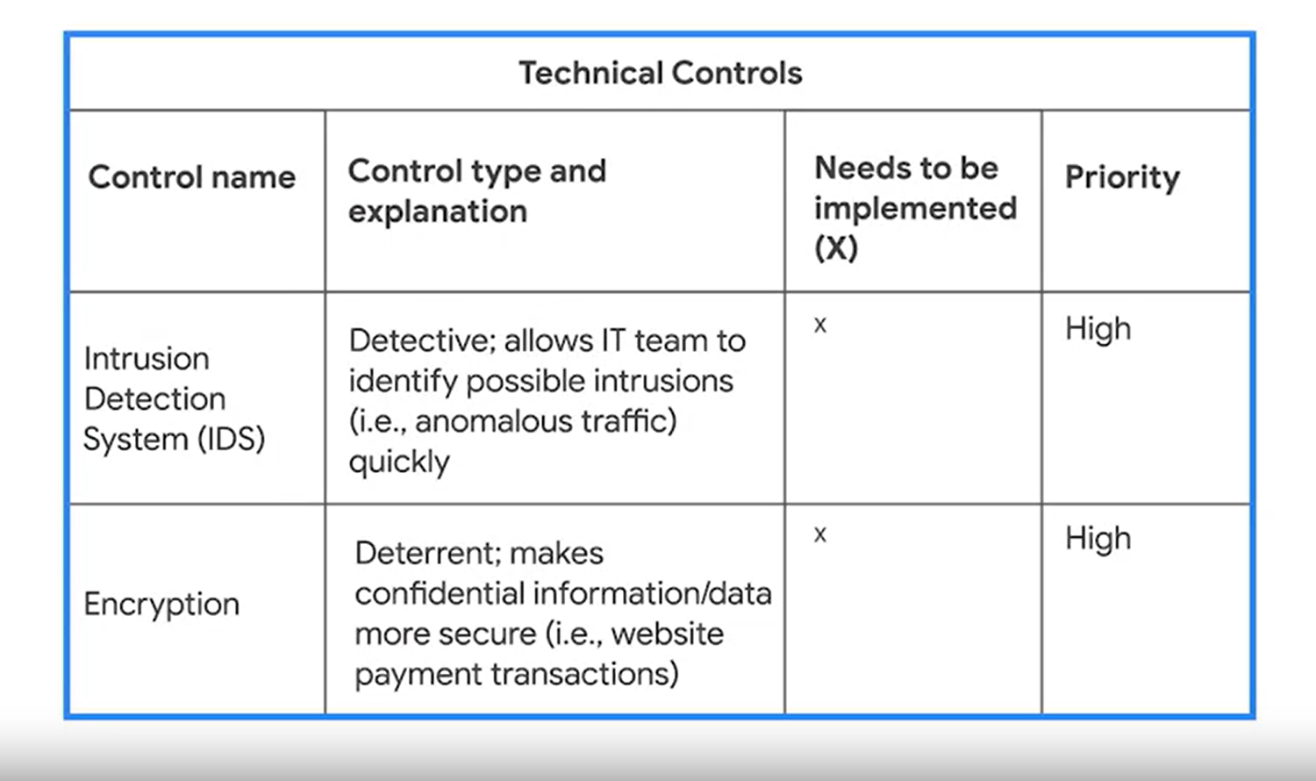

1. Physical Controls are physical solutions to protect protected assets e,g surveillance camera, access key cards

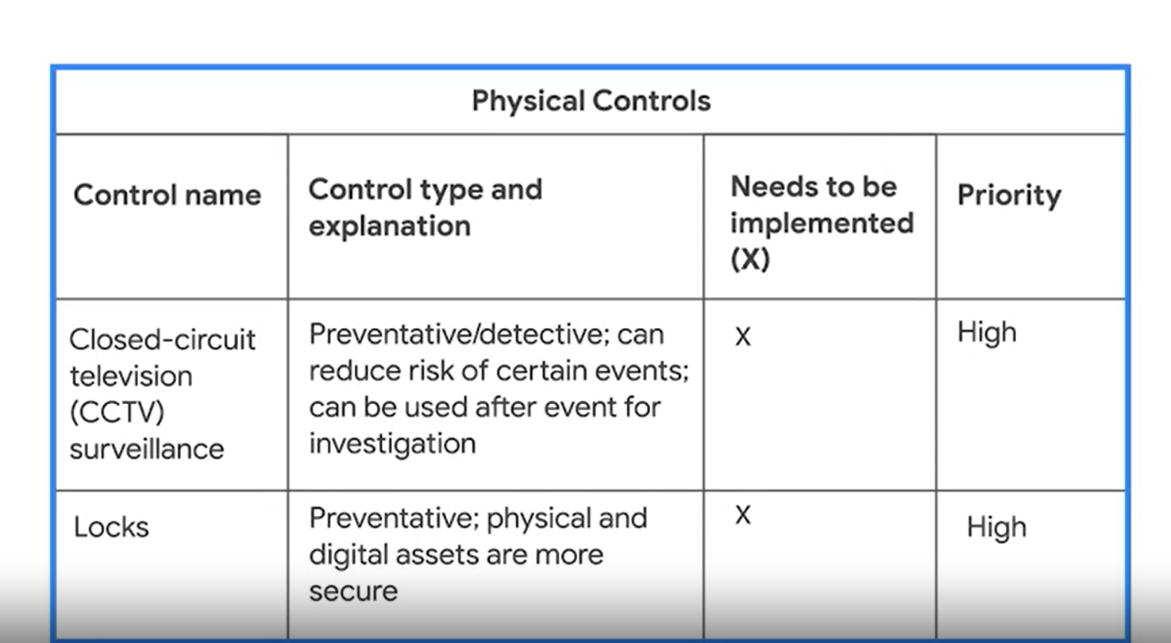

1. Assessing compliance

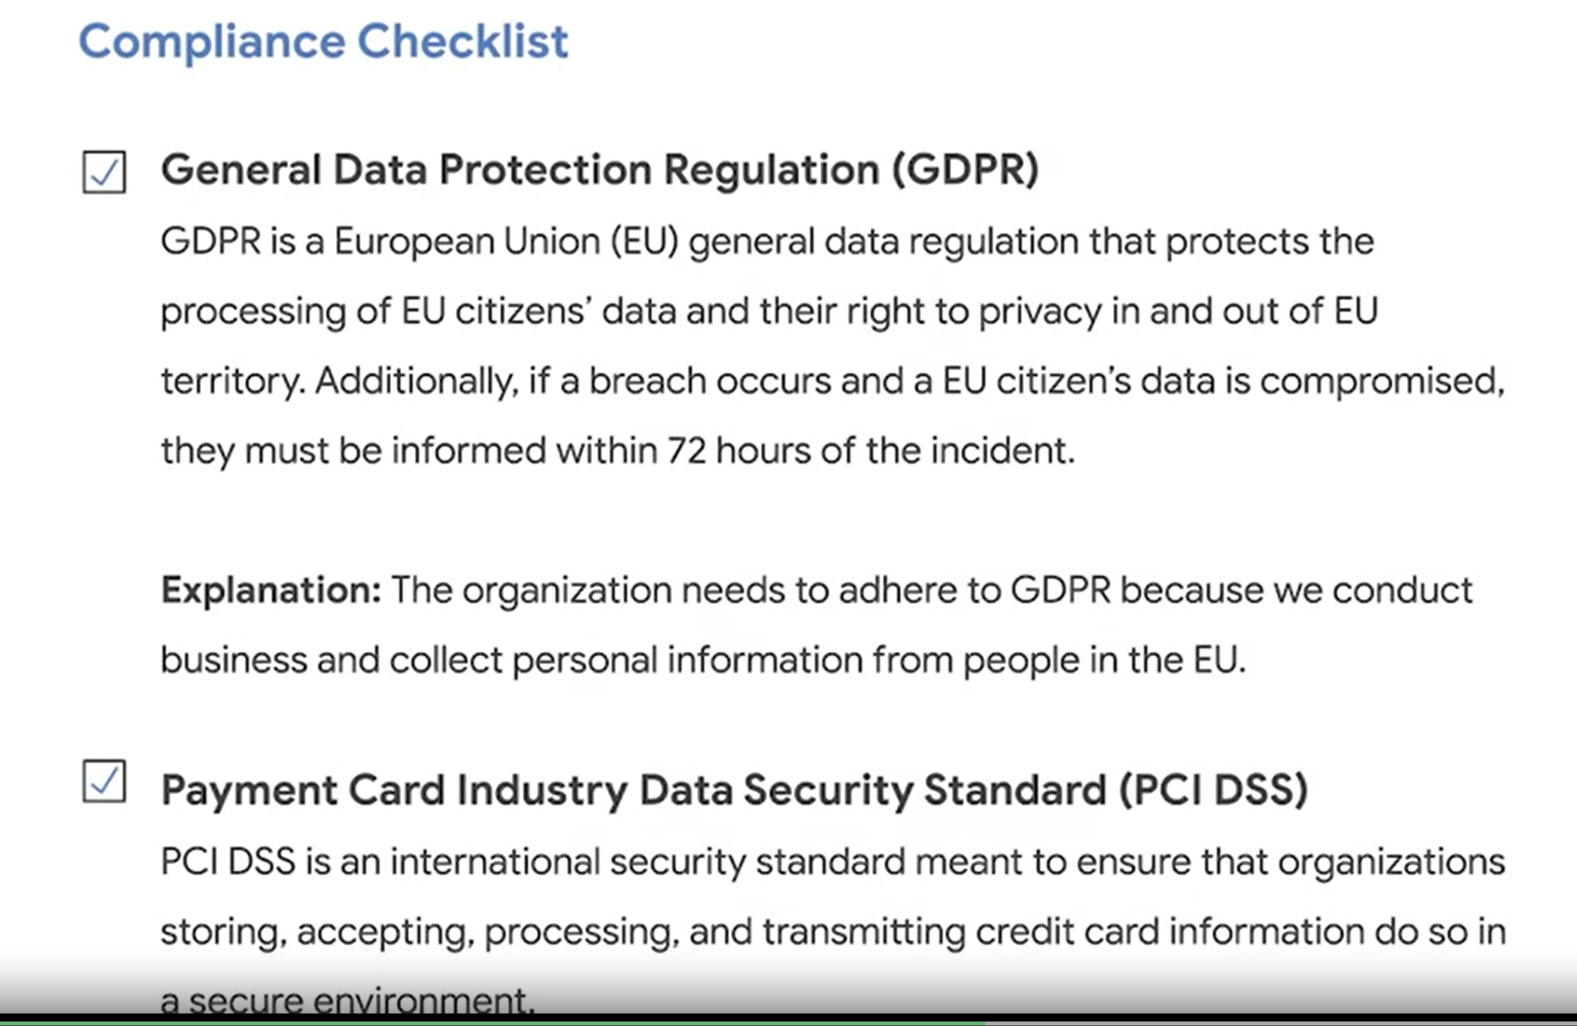

1. Communication results and recommendation needed to improve the security posture to all stakeholders

